DBMS – LAB -EXAM

**NAME** : RAHUL VARMA

**ROLL NO**: S20200010212

**SECTION**: C

**TASK:** (LAB EXAM)

SQL COMMANDS

1)CREATING THE TABLES:

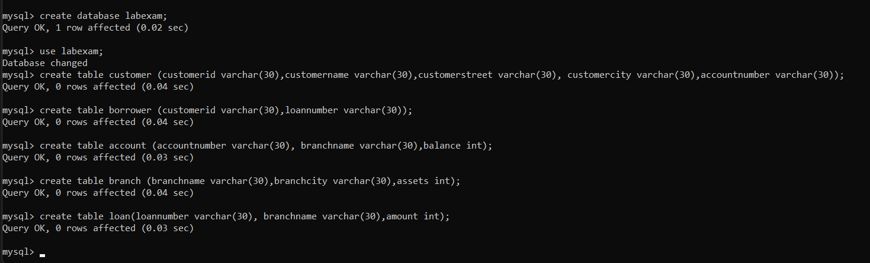

2) AlterIing the above created tables with appropriate constraints.

(I didn’t considered foreign key (no need as per the Questions))

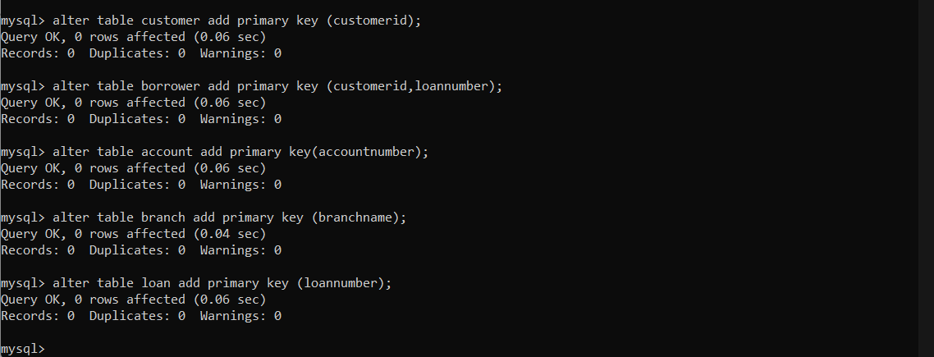

3)

a),b)

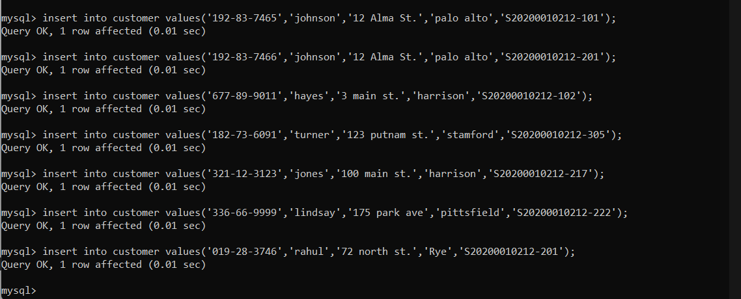

c)

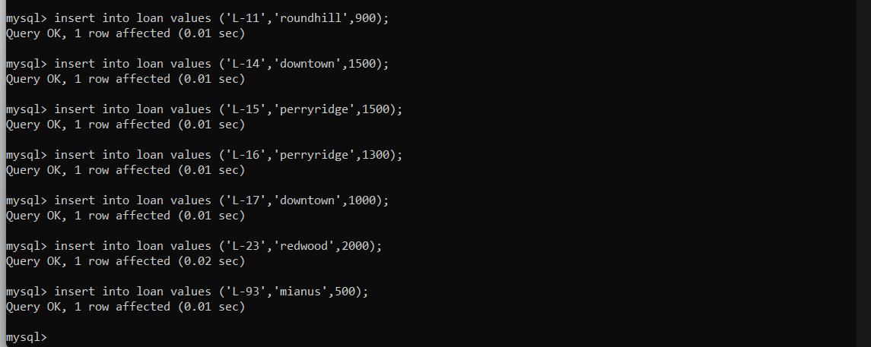

d)

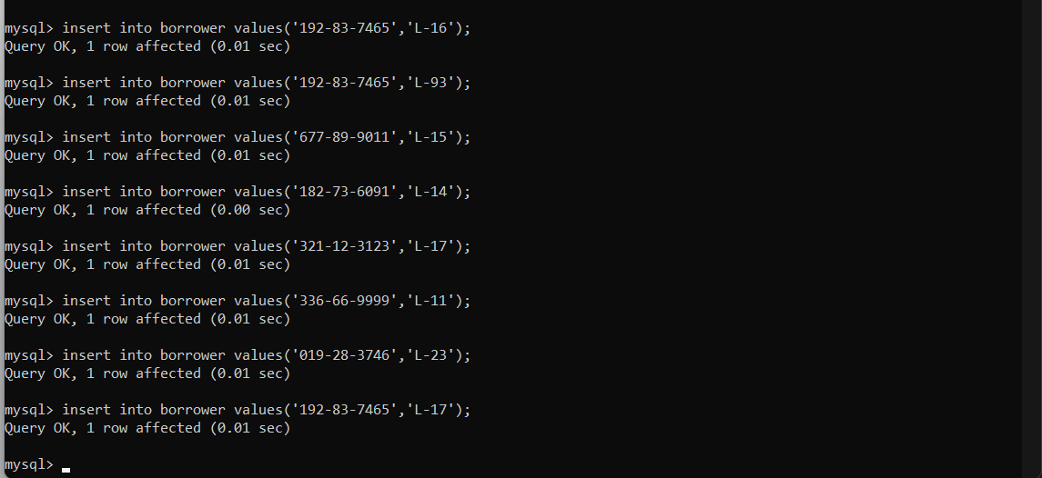

c

e)

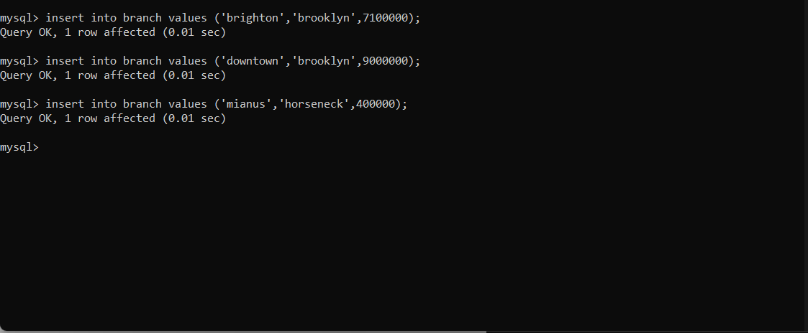

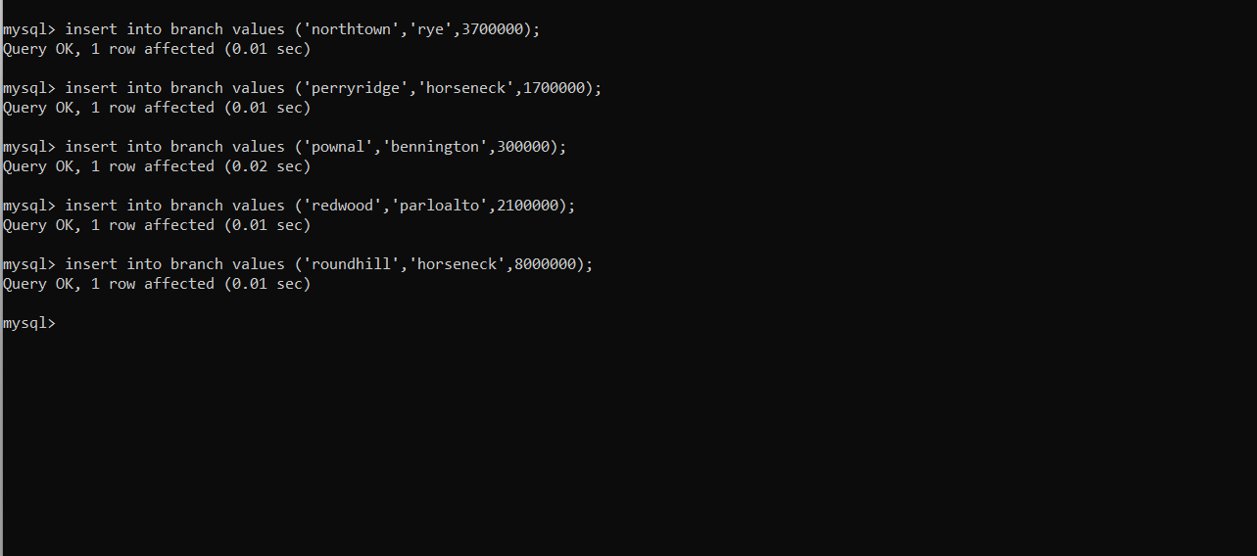

f)

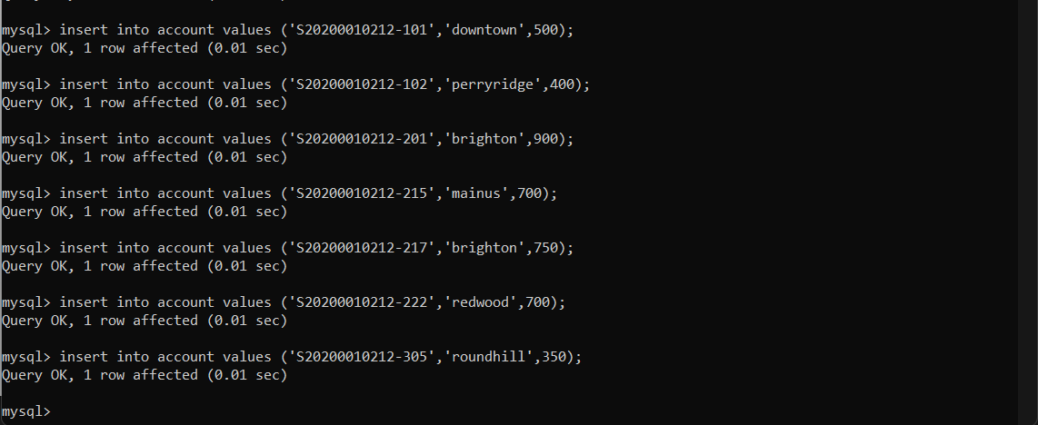

bc

FINAL TABLES:

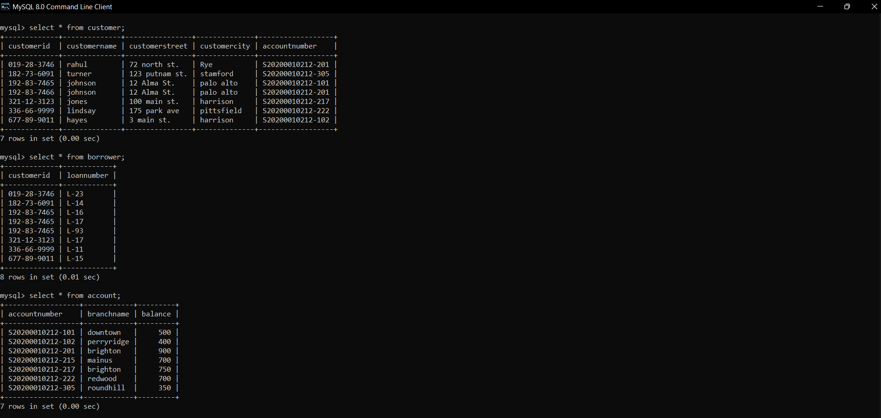

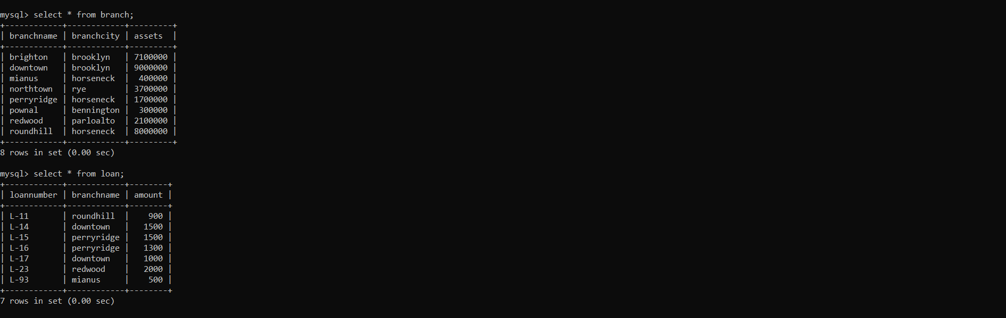

4)

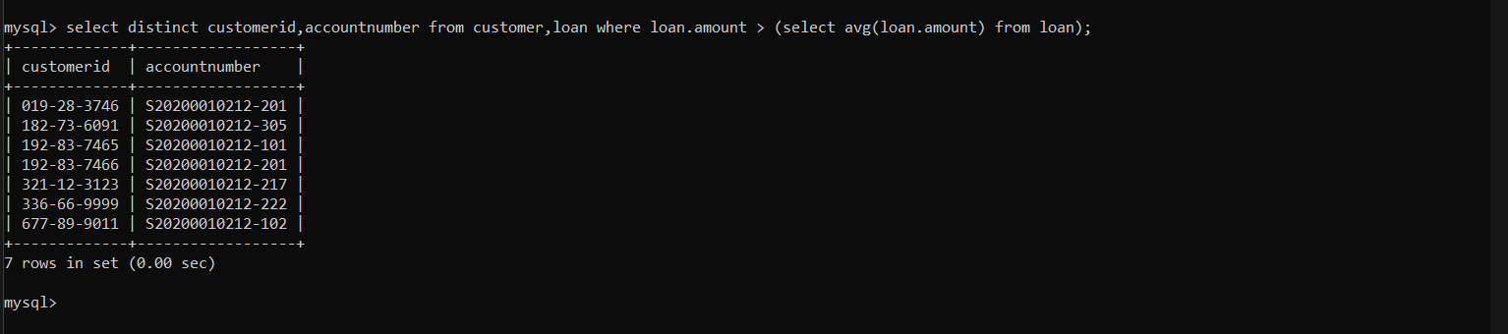

b

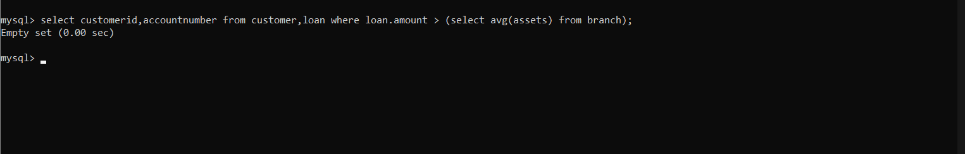

5)

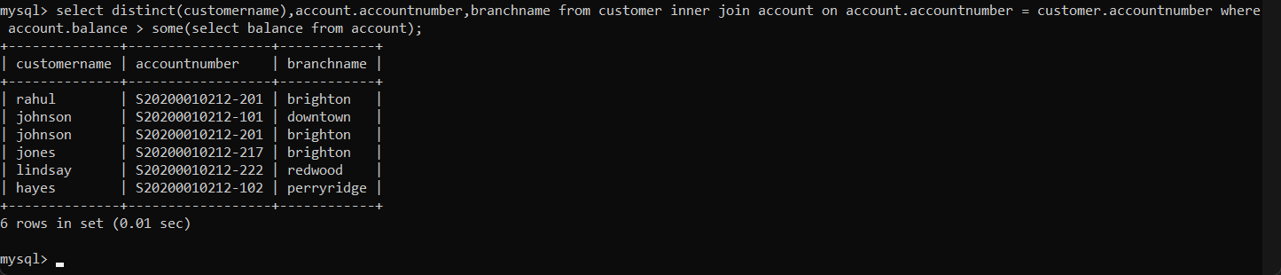

THANK YOU SIR